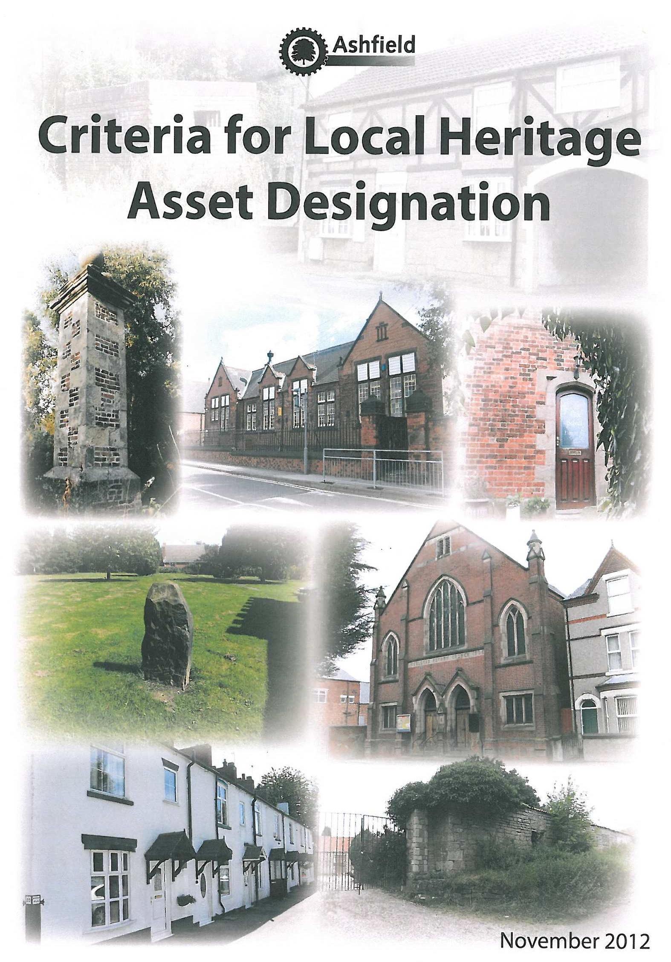

February 2013

Ashfield District Council
Criteria for Local Heritage Asset Designation

Contents

Section 1: Preface

Section 2: Introduction

Section 3: Relevant Planning Policies
3.1 National Planning Policy Framework (2012)
3.5 Emerging Ashfield Local Plan

Section 4: | Local | Heritage Assets
 | 4.1 | What is a Local Heritage Asset?
 | 4.5 | What is a Local Heritage Asset List?
 | 4.8 | How and when are Local Heritage Assets identified?
 | 4.9 | What does it mean if a building or structure is on the Local Heritage Asset List?
Section 5: | Local | Historic Distinctiveness
 | 5.1 | The Colliery Industry
 | 5.2 | The Textile Industry
 | 5.3 | The Medieval Landscape
 | 5.4 | Vernacular Architectural Traditions

Section 6: Criteria for identifying a Local Heritage Asset ELEMENTS OF INTEREST
  - Historic interest
  - Archaeological interest
  - Architectural interest
  - Artistic interest

ELEMENTS OF SIGNIFICANCE
  - Measuring significance: Rarity
  - Measuring significance: Representativeness
  - Measuring significance: Aesthetic Appeal
  - Measuring significance: Integrity
  - Measuring significance: Association

Section 7: | Types | of Local Heritage Assets
 | 7.1 | Building and Structures
 | 7.2 | Archaeological Sites
 | 7.3 | Landscapes and Landscape Features
 | 7.4 | Local Character Areas

Section 8: How to nominate a site for inclusion on the Local Heritage Asset List

Section 9: Consultation

Section 10: Sources of further information

Ashfield District Council Local Heritage Asset Nomination Form

SECTION 1

- Preface

  - Our local heritage and historic environment is an asset of enormous cultural, social, economic and environmental value, providing a valuable contribution to our sense of history, place and quality of life.

  - Recent changes in Government policy have given significant weight in planning decision-making to heritage assets that are not nationally designated. The National Planning Policy Framework, March 2012 (NPPF) advises local planning authorities to set out ‘a positive strategy for the conservation and enjoyment of the historic environment’ in their Local Plan. Emphasis is placed on ‘sustaining and enhancing the significance of heritage assets’ and recognising that heritage assets are an ‘irreplaceable resource’ and should be considered ‘in a manner appropriate to their significance’. Heritage assets are defined in the NPPF as:

“A building, monument, site, place, area or landscape positively identified as having a degree of significance meriting consideration in planning decisions, because of its heritage interest. Heritage asset includes designated heritage assets and assets identified by the local planning authority (including Local Listing).”

  - Local listing is a means for the local community and the local planning authority to jointly decide what it is in their area that they would like recognised as a ‘local heritage asset’ and therefore worthy of some degree of protection in the planning system. This document sets out the process through which Local Heritage Assets will be identified, via a set of criteria consistent with Government policy and associated guidance from English Heritage.¹

¹ Good Practice Guide for Local Heritage Listing, English Heritage, May 2012. Available at http://www.english-heritage.org.uk/content/publications/publicationsNew/guidelines-standards/good- practice-local-heritage-listing/local-listing-guide.pdf

SECTION 2

- Introduction

  - Ashfield has a rich history in agriculture, coal mining, textile and aerospace engineering, all of which have helped to create a distinctive historic character for the area, which is evident in the pattern of development and architectural features throughout the District. Consequently, the District has a diverse range of ‘Heritage Assets’, the name given to those parts of the historic environment that have significance because of their historic, archaeological, architectural or artistic interest.²

  - Where Heritage Assets possess a level of interest that justifies designation they are afforded protection against detrimental changes. In Ashfield Designated Heritage Assets include Listed Buildings, Scheduled Ancient Monuments, Registered Parks and Gardens and Conservation Areas.

  - The District of Ashfield has 79 buildings and other structures, which are of sufficient architectural and historic importance to be included on the statutory list of Listed Buildings. Nine sites within the District are currently scheduled as Ancient Monuments under the Ancient Monuments and Archaeological Areas Act 1979. Two designated landscapes are on the English Heritage Register of Parks and Gardens of Special Historic Interest, and four Conservation Areas have been designated at Kirkby Cross, Lower Bagthorpe, Teversal and New Annesley. Information on these sites can be viewed on English Heritage’s website at: http://www.english- heritage.org.uk/professional/protection/process/national-heritage-list-
for-england/

  - However, there are many other Heritage Assets which do not meet the criteria for inclusion on the statutory list but still make a significant contribution to the character and appearance of the District of Ashfield.

  - In recognition of the contribution of these heritage assets make to the District of Ashfield, the Council has acknowledged the importance of these assets and has followed Government policy by creating a Local Heritage Asset List, together with a policy in the emerging Local Plan to afford them appropriate protection.

  - These non-designated locally important heritage assets can be found throughout the District not just in areas of obvious heritage interest such as town centres. Illustrations of a selection of buildings and other features included on this list are given as examples in this document.

2 As defined by Annex 2 of NPPF (March 2012).

  - The absence of any particular heritage asset on the local list should not be taken to imply that it has no heritage value, simply that it has yet to be indentified or it does not currently meet the selection criteria.

SECTION 3

- Relevant Planning Policies

National Planning Policy Framework (2012)
  - The National Planning Policy Framework (NPPF) sets out the Government’s planning policies for England and how these are expected to be applied. Whilst the NPPF does not change the status of the Local Plan as the starting point for planning decision-making in Ashfield, the NPPF is still a material consideration in determining planning applications.

  - Section 12 (paragraphs 126-141) of the NPPF covers all aspects of the historic environment. Paragraph 126 makes the Government’s position on heritage very clear, stating that:

“Local Planning Authorities should set out in their Local Plan a positive strategy for the conservation and enjoyment of the historic environment, including heritage assets most at risk through neglect, decay or other threats. In doing so, they should recognize that heritage assets are an irreplaceable resource and conserve them in a manner appropriate to their significance. In developing this strategy, Local Planning Authorities should take into account:

    - The desirability of sustaining and enhancing the significance of heritage assets and putting them to viable uses consistent with their conservation;
    - The wider social, cultural, economic and environmental benefits that conservation for the historic environment can bring; and
    - Opportunities to draw on the contribution made by the historic environment to the character of a place.”

  - With specific regard to the identification of heritage assets, paragraph 141 of the NPPF states that:

“Local Planning Authorities should make information about the significance of the historic environment gathered as part of plan- making or development management publicly accessible.”

  - It is considered that this criteria document provides the public with, at the earliest possible stage, a set of clearly-defined, coherent and concise criteria with which the Council will identify heritage assets across the District.

Emerging Ashfield Local Plan
  - The Ashfield Local Plan Review (2002) will be replaced over the next few years by a new Ashfield Local Plan. It is proposed that a policy to protect Local Heritage Assets will be included in the document. The proposed policy will seek to prevent the loss of buildings or assets

identified on its Local Heritage Asset List and encourage the retention, restoration and continued beneficial use of these assets wherever possible.

  - This guidance document will be updated in due course to reflect the new policies contained within the emerging Local Plan, and shall be a material consideration when proposals affecting heritage assets are being determined. Details of the progression of the Local Plan can be obtained by contacting the Council’s Forward Planning Team.

SECTION 4

- Local Heritage Assets

What are Local Heritage Assets?
  - As the term suggests, Local Heritage Assets are those identified by the Local Planning Authority that are not statutorily recognized (e.g. Listed Buildings designated by English Heritage). However, being identified as a Local Heritage Asset is in itself a material consideration for planning decisions.

  - Local Heritage Assets are buildings, structures, historic settlements, archaeological sites, landscapes or landscape features regarded by local people as being important to their environment, either because they are of historic, archaeological, architectural or artistic interest. However, they must also have a degree of significance, either through their rarity, representativeness, aesthetic appeal, integrity or association with groups or individuals in the part.

  - Local Heritage Assets help build a sense of local identity and distinctiveness, a sense of history, place and belonging.

  - Due to the nature of Local Heritage Assets, some of which are either in private ownership or in isolated locations, access may be restricted.

What is a Local Heritage Assets List?
  - The Local Heritage Asset List (Local List) is intended to recognize non- designated buildings or structures so that they can be properly considered when development proposals are submitted to the Council.

  - Heritage assets on a Local List do not enjoy the same protection as Statutorily Listed Buildings and at present there is no power for local authorities to prevent demolition of Locally Listed buildings unless they are in a conservation area. The government has indicated however that if a Local List is supported by a policy in the Local Plan it can add weight to arguments for the protection of listed items when planning applications are considered.

  - Some Local Heritage Assets identified on the Local List also lie within a Conservation Area. They are included on the ‘Local List’ because they are not afforded protected by the Conservation Area designation itself, these include items such as street furniture.

How and when are Local Heritage Assets identified?
  - Local Heritage Assets are likely to be identified by the Local Planning Authority in several different ways:

By nomination
The normal starting point of Local Listing is a nomination from the local Parish Council or perhaps a local heritage group, but nominations can also be received by interested members of the public if they wish.

In Local Character Studies
The most common type of character study undertaken by the District Council’s Forward Planning Team is a Conservation Area Appraisal (CAA). However, within a Conservation Area, heritage assets are considered to be designated for the purposes of planning decision- making. Notwithstanding this, non-designated heritage assets outside of a Conservation Area boundary (either within its setting or nearby) are often identified within CAAs.

On the Historic Environment Record (HER)
The Historic Environment Record, (HER) held and updated by Nottinghamshire County Council, identifies several types of heritage assets, both designated and non-designated. In terms of non- designated assets, those identified on the HER include non-registered parks and gardens, local interest buildings/structures, archaeological areas/find spots and historic village cores. Numerous studies relating to these assets and more specific areas such as schools and bridges are also contained within the HER. The HER should always be consulted before any application is made that is likely to affect a heritage asset.

At the pre-planning application stage
During pre-planning application discussions, it may emerge that a site affected by a proposal meets the criteria for identification as a heritage asset as set out in this document. If this is the case, the developer/agent will be informed and be required to produce a heritage statement at the application stage.

At the planning application stage
If no pre-planning application discussions have taken place and a planning application is submitted, it may emerge that the site affected may be identified as a heritage asset. The developer/agent may be required to submit a heritage statement at this stage.

What does it mean if a building or structure is on the Local Heritage Asset List?
  - Inclusion on the Local Heritage Asset List does not in fact change the existing planning controls that apply to a building/structure already.

  - The Local Heritage Asset List reinforces efforts to preserve the character and appearance of the buildings/structures that are included on it.

  - It enables the architectural or historic interest of these buildings/structures to be properly considered against development proposals submitted to the Council.

  - It provides clarity for owners, the local community, developers and Planning Officers, so that they are aware of the interest of a building/structure as early as possible.

  - The Local Heritage Asset List backs up our existing planning policies and guidance, adding weight to the consideration already given to the preservation of these buildings/structures architectural and historic interest by development proposals affecting them.

SECTION 5

- Local Historic Distinctiveness

Ashfield District has a rich history reflected in its buildings and landscapes. Whilst it is accepted that many buildings and landscapes are common nationally, the materials from which they are built or the reason why they were built are not and can be considered to be distinct and specific to the region and District. Furthermore buildings and landscapes exist in the District that have been lost in other areas. The following are considered as themes that reflect the local historic distinctiveness of the District. Many local heritage assets will fall under these themes.

The Colliery Industry
The colliery industry is the most significant aspect of recent heritage that has shaped the District and is an industry with which many local people have a strong affinity with. Coal mining, albeit on very basic scale, could well have taken place in Ashfield since Roman times when coal from the Nottingham region was documented as being shipped to the fens, probably as return cargo for grain. There is evidence that coal was being widely burned as fuel for lime burning, baking, brewing and iron forging in the Nottingham area as far back as the 1200s.
The first documented mine lease was awarded in 1316, at this time mining would have taken place in the form of quarrying into an exposed coal seam although this was soon superseded by the bell-pit method which remained in existence until the 19th Century. Despite a large number of bell-pits springing up from the 1600s onwards, and the rise of canal based transportation, mining remained a localised market until the mid-19th Century when the railways finally allowed the bulk transportation of coal products right from the centre of the coal field out to the rest of the UK.
Coal mining dominated Ashfield’s economy from the mid-19th Century onwards and, with twelve active collieries in its heyday, sealed Ashfield’s status as Britain’s wealthiest region. From the 1970s onwards, however, the industry has been in steep decline. January 2000 saw the closure of Annesley Bentinck Colliery (Ashfield’s last), marking the district’s departure from a 1000 year or more association with the industry.
Despite the impact of the colliery industry being easy to see in the District there is still much research required to fully understand the significance of the many heritage assets, not only the industrial, but social and recreational too. This is a research area that is likley to be undertaken by Nottinghamshire County Council and English Heritage.

The Textile Industry
The East Midlands region has a history of textiles manufacture dating back to the Domesday Book. As the Peak District in Derbyshire became

Britain's centre for sheep farming a ready supply of raw materials began to find its way into the East Midland towns. Consequently, Leicester has a long tradition of hosiery manufacture and Nottingham is famous for its lace making. By the early 17th Century an extensive framework knitting industry had established itself in the settlements of Kirkby, Sutton and Selston. As the industrial revolution took hold, textile manufacturing companies thrived in Ashfield providing employment for the wives of the local miners.
By the 1960s a combination of the district’s twelve highly productive collieries and approximately 40 textiles factories producing hosiery and allied products, employing 60% of the female labour force, had given Ashfield one of the highest average incomes of any industrial area in the country.

The Medieval Landscape
The medieval landscape can still be understood in areas across the District. Sherwood Forest is internationally known and during the medieval period Ashfield was subject to the ‘forest law’ which protected the habitat of the area. Whilst heritage assets such as Skegby Manor and Wansley Hall are designated the landscapes that surround them and medieval villages are often not, features such as the ridge and furrow of the fields remind us of this period and the feudal system. Recent archaeology at Kirkby Hardwick Hall has revealed another substantial medieval residence in the District. Further research of the medieval landscape is likely to reveal more sites of significance across the District.

Vernacular Architectural Traditions
Before the advent of mass transportation of materials along the canal, railway or road network materials for building were sourced locally. These materials, coupled with design formed the vernacular tradition which makes these pre-19th century buildings of the District distinct from those in other regions of the country. The geology of the area consists of sandstones of the coal measures overlain by magnesian limestone, this provided the building stones of the District pre 19th - century thus forming the backbone of architectural interest and local distinctiveness. With regards to roofing materials stone slates more akin to the Derbyshire tradition are found across the District, although their numbers are limited whereas natural clay pantiles form a strong part of the District’s vernacular. Internally a feature worthy of acknowledgement are reed and plaster floors. Often mistaken for concrete they are in fact lime or gypsum plaster laid over a reed bed. They are particularly unique to the region, which is a reason why they are so often misunderstood. Further research again is required for a greater understanding of their significance but they are of historic significance to Ashfield and Nottinghamshire.

SECTION 6

- Criteria for identifying a Local Heritage Asset

  - The definition set out in the NPPF states that a heritage asset is:

“A building, monument, site, place, area or landscape identified as having a degree of significance meriting
consideration in planning decisions, because of its heritage interest. Heritage asset includes designated heritage assets and assets identified by the local planning authority (including local listing)”.

However, in order for an asset to have any significance at all, it must have a degree of historic, archaeological, architectural or artistic interest to begin with, as advised by English Heritage.³

  - If the site is of interest, it will then be judged on its significance. English Heritage’s Conservation Principles document defines significance as “the sum of the cultural and natural heritage values of a place, often set out in a statement of significance” (English Heritage, 2008). The significance of a site can be measured in terms of how it meets any of the five criteria, these being: rarity, representativeness, aesthetic appeal, integrity or association.

  - The diagram below shows the relationship between interest and significance. In order for a site to be considered a Local Heritage Asset, it must have at least one element of interest and one element of significance.

ELEMENTS OF INTEREST ELEMENTS OF SIGNIFICANCE
Archaeological Interest
- Rarity

- Representativeness

- Aesthetic Appeal

- Integrity

- Association
Historic Interest

Diagram showing the relationship between interest and significance.
Artistic Interest
Architectural Interest

³ As advised by Annex 2 of the NPPF

Sections 6.4 to 6.7 examine the types of interest a potential heritage asset may have. Sections 6.8 to 6.12 provide criteria that can be used to assess the significance of this interest.

ELEMENTS OF INTEREST

  - Historic Interest
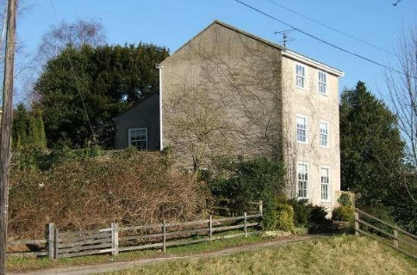
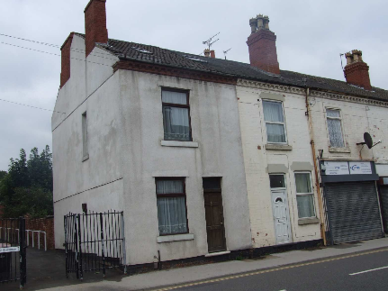
In terms of historic interest, an asset should have importance in relation to events or people in the past, either as a direct representation of the particular event/group of people (such as a purpose-built structure like a chapel) or by the historical use of a building/site for a particular practice. Sites/structures with historic interest not only provide a physical record of our past, but also contribute to an area’s sense of place, individuality and cultural identity. For these reasons, these types of sites and structures can have considerable local (and sometimes regional) importance in terms of their contribution to local character and distinctiveness. Where a site/structure is identified as having a national importance, it is likely that these would be put forward for national designation.
Quaker House, Mansfield Road, Skegby; Birth place of Eric Coates (composer),
A house where some of the earliest Quaker 140 Watnall Road, Hucknall; Once owned by meetings were held. the father of Eric Coates, where Eric lived
until the age of 4

Archaeological Interest
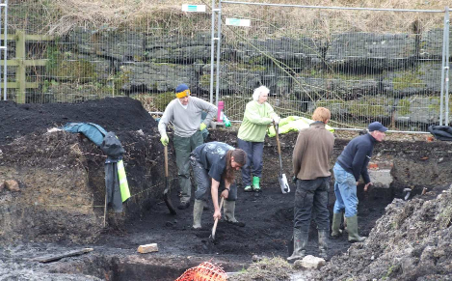
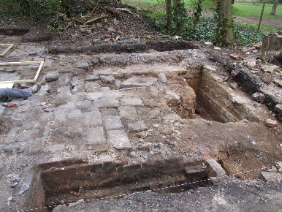
Heritage assets that contain archaeological remains are the primary source of information about the historical development of places and the people who inhabited them in the past. These assets form part of a picture of the past that spans from the hunter-gatherers to the present day. Sites of archaeological interest may be detected through development works, agricultural practices, archaeological studies, metal detecting, and studies of aerial photography or brought forward by local residents, although identification (and inclusion on the Nottinghamshire HER) will need to be in conjunction with Nottinghamshire County Council’s Archaeology Team.
Wharf Green, Jacksdale; Site of a former Kirkby Hardwick, Penny Emma Way, Kirkby in canal basin, wharf and early tram line. Ashfield. Site of a former Manor House dating
back to the mid thirteenth century.

Architectural Interest
Assets that are of architectural interest are identified because of their design, construction, craftsmanship or decoration. Such assets help reinforce the individual sense of place and may be a physical representation of a particular type/era of architecture, a particular architect (of local or regional importance) or company. Such design may be individually distinctive or represent a style notable in that area.
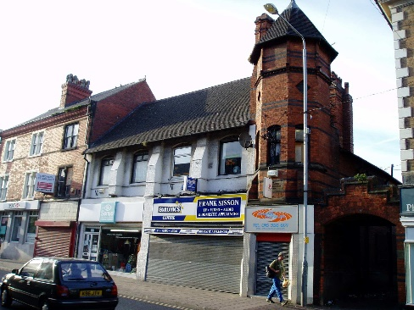
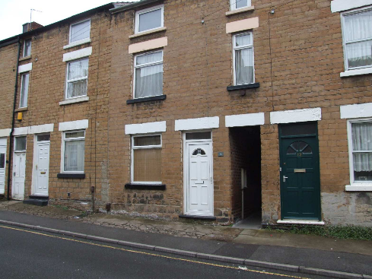
Watson Fothergill Property, High Street, Framework Knitter Cottages, Albert Street, Hucknall; Ornate Victorian property, Hucknall: Examples of three story cottages featuring a tower, designed by the well designed for framework knitting machines to known Nottinghamshire architect. be installed on the top floor.

Artistic Interest
An asset with artistic interest will exhibit some degree of creative skill in its creation, design or later alteration, whether through sculpture, painting or other method of decoration (including for advertising purposes). Assets with artistic interest may include structures such as war memorials, gate piers or railings. In addition, decorative elements on buildings or structures, such as finials, roof bosses, door surrounds or signage, may also hold a degree of artistic interest.
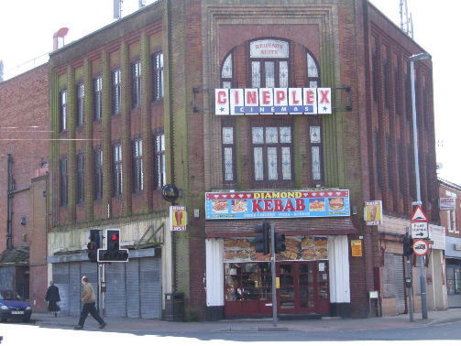
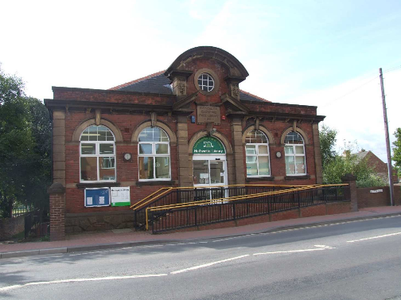
Regent Cinema, Kingsway, Kirkby: Designed Huthwaite Library, Sutton Road, Huthwaite:
by Alfred Thraves a local cinema architect and Built in 1912 this library features an artistically opened in 1930. This cinema has an imposing designed front façade.
decorative façade.

ELEMENTS OF SIGNIFICANCE

  - Measuring significance: Rarity
For an asset to have a degree of rarity (whether it be a building, archaeological site, landscape, landscape feature or settlement), it must exemplify a design, settlement pattern, or other quality that is in itself uncommon, either to the locality, district or wider region. A building for example may be of considerable age but may not necessarily be particularly rare.
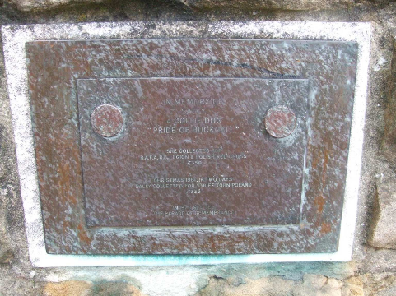
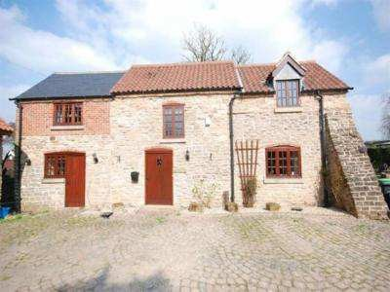
Dog Memorial, 32 West Street, Hucknall: The Dovecote, Old Road, Skegby; This is
A rare example of a public memorial to a the only surviving dovecote within Ashfield, charity fund raising dog. which has recently been converted into a
private residence.

Measuring significance: Representativeness
An asset may not necessarily be rare; instead it could be representative of a particular historical or architectural trend. It may also be the part of the legacy of a particular individual, architect, architectural movement, programme of works, company or group in the past.
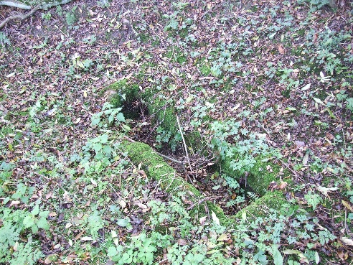
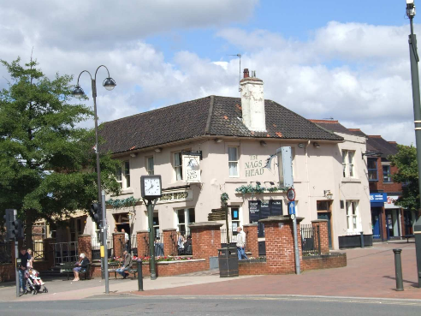
Bagthorpe Trough, Church Lane, Bagthorpe; Nags Head PH, Station Street, Kirkby in Representative of scores of troughs that Ashfield; Representative of dozens of once lay across the district but is sadly now Victorian public houses that once spread one of only three still in situ in the district. across the district resulting from the
establishment of the mining industry.

Measuring significance: Aesthetic appeal
The asset may evoke positive feelings of worth by reason of its architectural, design or artistic quality or in its form and layout. It may also have either a harmonious or diverse use of materials and design features to give an overall attractive external appearance in the streetscene. An asset with aesthetic appeal will usually be in a decent or good physical condition, or in a state which can easily be restored.

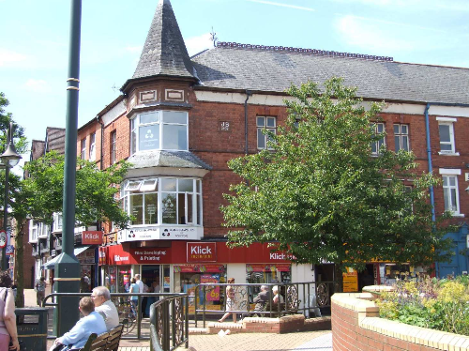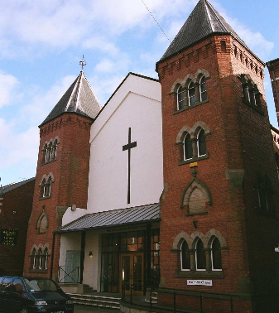
John Briggs Chemist Shop, Portland Square, Watnall Road Baptist Church, Hucknall; Sutton-in-Ashfield: Constructed in 1892 this Featuring an imposing entrance and twin Imposing structure overlooks the whole square. majestic towers that immediately catch
your eye.

Measuring significance: Integrity
To have a degree of integrity, an asset should retain a sense of completeness, either as an individual building, structure or landscape feature, or as part of a larger group. The asset may also express either a single-phase of development, or encompass multiple phases, as can often be found with residential properties or farmsteads.
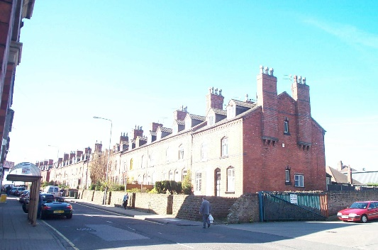
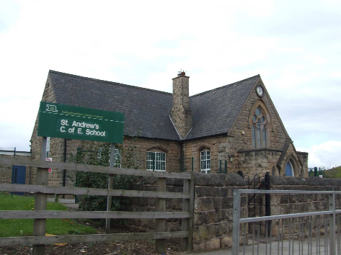
Watnall Road Miners Houses, Hucknall; These St Andrews School, Mansfield Road,
still retain their solid yet decorative image and Skegby: Constructed in 1865 and still being remain significant terraced houses. used for its original purpose.

Measuring significance: Association
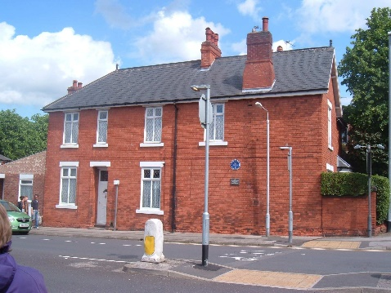
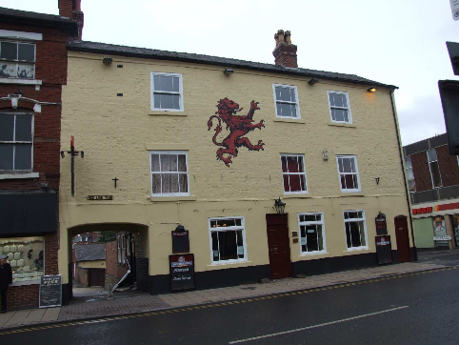
Evidence may suggest that an asset is associated with a particular person or historic event. This may relate to a particular landowner, commemoration (often of royal events), charity, religious group or other group in the past. Examples may include sites previously inhabited, designed or constructed by well-known or locally prominent individuals or groups of people. Even where the association cannot be proved, certain sites may be valued for associations that are based on local tradition rather than historical fact.
Eric Coates House, 182 Beardall Street, Red Lion Public House, High Street, Hucknall: Hucknall; Former childhood home of the Dating back to the 1750’s this property is world famous composer. often referred to as ‘Byron’s Rent House ‘
because this is where his steward would come to collect rents from his tenants. It is the oldest proved public house in Hucknall.

SECTION 7

- Types of Local Heritage Assets

Buildings and Structures
The Historic Environment Record (HER) has already identified many buildings and structures of local historic interest. The HER should always be consulted prior to the submission of applications affecting both designated and non-designated heritage assets. However, the HER is by no means exhaustive and many buildings and structures
that may be identified as local heritage assets are not shown on the HER. The following sections highlight the different types of buildings/structures that may be identified as local heritage assets.⁴

Agricultural
Ashfield has a good range of agricultural buildings/structures built in a variety of materials and architectural styles, either within a group or stand alone. Agricultural buildings will often reflect the vernacular tradition of the District.

Agricultural buildings/structures may hold significance in terms of their architecture or their historic role in the area (e.g. pinfolds). As heritage assets, such buildings and structures may be of a variety of styles, use a range of materials and date from periods between the 18th and the 20th century (all earlier structures are likely to be nationally designated). Buildings/structures may also be significant because of internal features such as flooring, troughs or other equipment. Historic alterations to such buildings and structures may also highlight changes to both the particular building and farming practices over time.
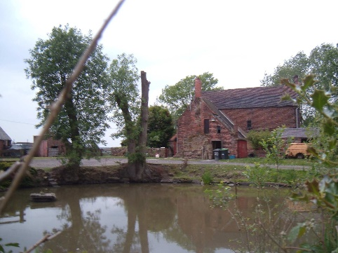
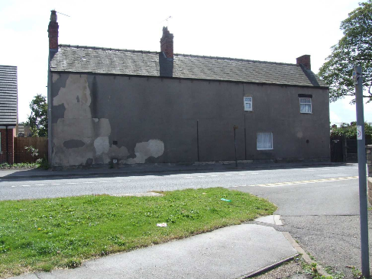
Ashes Farm, Nottingham Road, Selston; Cowpasture Farm, High Pavement, Sutton; A seventeenth century farm with the Districts Believed to be Sutton’s oldest surviving only surviving farmyard duck pond. Farm building.

Commemorative Structures
Commemorative structures including memorials, statues, funerary monuments, gravestones, tombs and plaques are of considerable importance both in terms of their contribution to local identity and in their aesthetic qualities. Such structures are present in most settlements and are constructed in a variety of different designs and materials for a

⁴ Please note that given the nature of some of the assets identified, some may fall into more than one category.

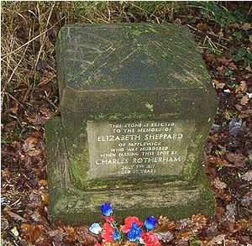
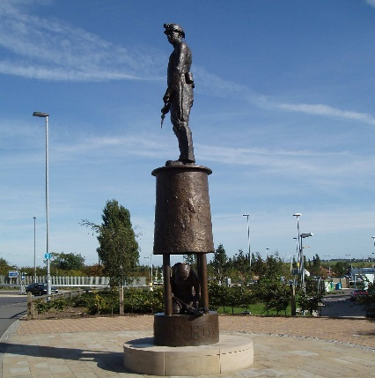
variety of purposes. Other than those given statutory protection (either listed or within the setting of listed buildings), a large number of non- designated commemorative structures contribute significantly to the character and history of an area. Initially, these structures can be viewed as representations of the artistic styles and social values of the time. In addition to this however, they can provide a physical link to the past and often provide a valuable insight as to the importance or status of the person/people commemorated.
Bessie Shepherd’s stone, Nottingham Road, Miner’s Statue, Station Road, Hucknall; Harlow Wood; Commemorates the location Tallest statue in Nottinghamshire where this person was murdered. commemorating the Hucknall collieries.

Commercial
Commercial buildings and structures can make a valuable contribution to the character of the historic environment and often provide an element of continuity in an otherwise constantly changing urban and rural landscape. Shops, public houses and offices, whether individually or locally distinctive, or representative of a particular company, may have an element of significance as heritage asset.

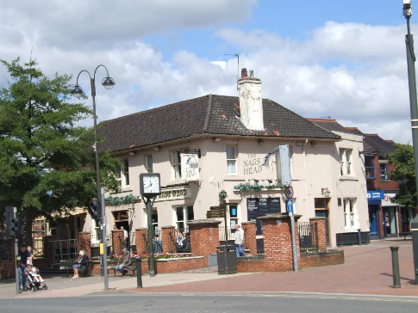
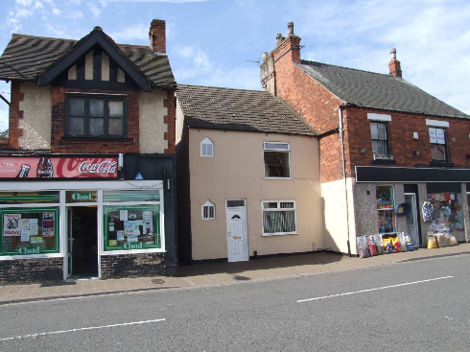
The physical attributes of the particular building or structure may be worthy of identification, as could the historical use of that site. In terms of design, Victorian and earlier structures often have a more decorative emphasis than post-WW1, where functionality became more dominant. Glazing may also be important, either in its extent or in the design of its fittings. Shop frontages or signage brackets are further examples of features that may contribute to the site’s significance as a heritage asset.
Nags Head, Station Street, Kirkby; Still High Street, Stanton Hill; Several Victorian functioning as a local public house after shops that are still used for their original 150 years of business. purpose, despite many changes all around
them.

Culture, Entertainment, Sport and Recreation
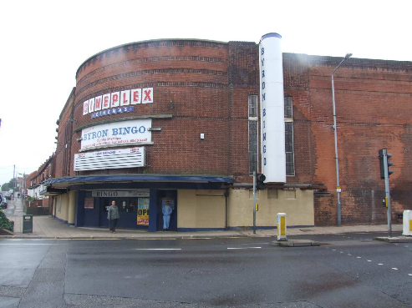
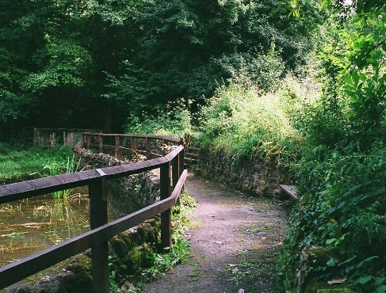
Whilst these buildings may be wide ranging in terms of scale and suitability of alternative use, what unites them is the pursuit of pleasure and escapism that led to their construction and in many cases the people they were built to serve. The burgeoning colliery population resulted in many social buildings being constructed, including the cinemas. Furthermore these buildings may have significance through association with celebrity or sporting figures. Such buildings/structures often have aesthetic detail that helps illustrate both the particular use and the era in which that particular structure was erected. These assets may include for example cinemas, libraries, dance halls and billiard halls. Given the types of uses involved, they often form an integral part of communities. As heritage assets, these buildings/structures should have a significant proportion of their original fabric remaining. In particular, those elements that identify or represent the original purpose of the building or structure should be intact.
Byron Cinema, High Street, Hucknall; A 1930s Portland Park, Lindley’s Lane, Kirkby; cinema still in use as an entertainment centre. A local park that is over 100 years old.

Domestic
These are the most numerous of all buildings and structures in the historic environment and unmistakeably exhibit both external and internal characteristics that help to place the structure into its particular era or architectural/artistic style. Historical alterations to dwellings are also easily dated, especially where in contrast to original architecture or materials.

Most dwellings can be classed as one of the following: vernacular houses (of local materials), town houses (18th century onwards, such as terraces and planned/regimented rows), suburban houses, country houses and modern estate housing. Houses that express an identifiable historic architectural style and retain much of their original fabric are likely to be considered as a heritage asset, especially where they form a group.

Investigation of historic plans held in archive is likely to lead to a better understanding of local architects from the 19th and 20th centuries, or reveal properties previously unknown that were designed by nationally renown architects or early example of new technologies.

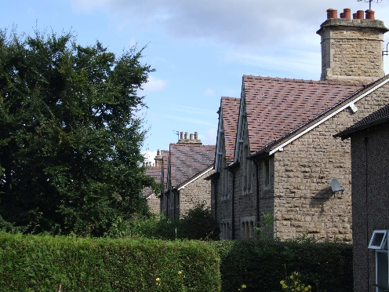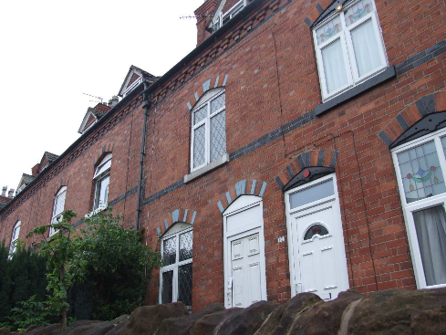
Miners Cottages, The Grove, Derby Road, Miners Mid Victorian Terraced Houses, 16-76 Annesley; Mid Victorian workers cottages Watnall Road: constructed specially for the built in a traditional estate workers cottage colliers who worked at the Hucknall colleries style with no front or side doors. and are typically symbolic of the type
constructed by mine owners for their employees.

Educational
Centres of education are amongst the most important local landmarks and their continued use (not only for educational purposes) reflects this. Post-WW2 schools (often concrete) were generally constructed using the pre-fabrication system CLASP. The technological and architectural significance is becoming more understood of CLASP buildings.

Nottinghamshire County Council have undertaken a review and identified those of particular significance dating to before WW2:

- Pre-board schools (pre-date the 1870 Education Act) often built by churches (called National Schools, such as in Sutton) or local benefactors (such as in Teversal).
- Board schools (built by locally elected School Boards) built between 1870 and 1904 and often designed by eminent local architects.
- Early Local Education Authority schools (1904-1911) designed by Nottinghamshire County Council head architect L.E. Maggs. Standardisation of design was common, including features such as marching corridors (Jacksdale and Kingsway Primary Schools are examples of this period).

Recent research by English Heritage has examined schools built between 1962 and 1988⁵ whilst the County Council are examining inter- war schools in the District which may reveal significant educational buildings.

⁵ England’s Schools 1962-1988. A Thematic Study. English Heritage 2012. http://www.english- heritage.org.uk/about/news/new-study-on-englands-schools-1962-88/

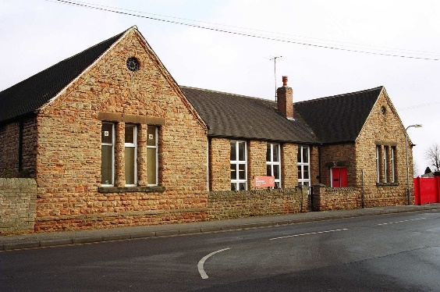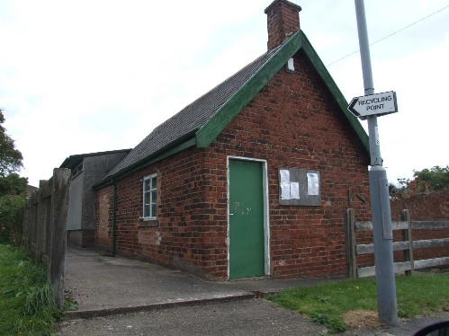
Beardall Street School, Hucknall; The oldest The Old Dame School, Fackley Road,
Board School in Nottinghamshire dated 1872. Teversal; Now part of the Ranch Scout Hut
this building was used as the local Dame School in the early to mid 1800s.

Health and Welfare
Buildings/structures erected for the purpose of caring for the sick, disabled, elderly and poor vary in size, scale and design, and illustrate how attitudes to those groups has changed over time. They were usually erected by the state, church or private charities/philanthropists. They are often recognisable with architecture, designs, or features repeated throughout the region or country, although may have local detailing or use local materials.
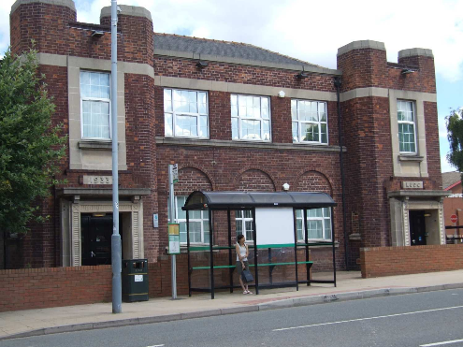
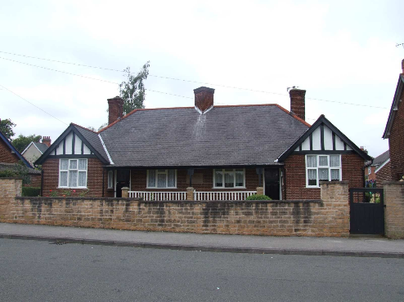
Ada Lovelace House, Urban Road, Kirkby; Elizabeth Ann Coupe Alms Houses, 66 & 68 Former clinic constructed during the 1920s. Garden Road, Hucknall; Constructed in 1929 as
retirement homes for the poor.

Industrial
As the birthplace of the industrial revolution, British settlements have an abundance of surviving industrial heritage, much of which is still used for its original purpose. Industrial buildings and structures may have significance because of their architectural style, design, construction materials or for what they manufactured and the importance this has to the locality or region. Such buildings and structures may also exhibit features related to their historical use.

Ashfield’s historic distinctiveness is firmly rooted in its industrial heritage including coal mining, textile milling and framework knitting

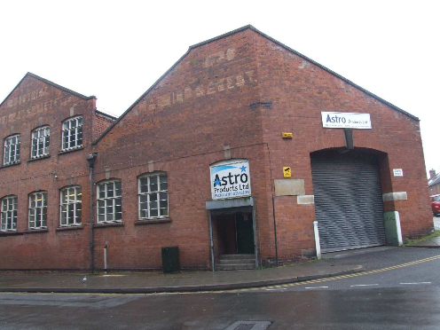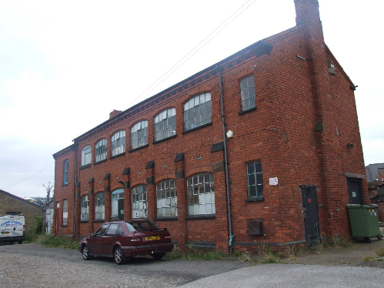
Astro Products, West Street, Hucknall; this was Certa Cito (The Old Forge), Bolsover Street, originally constructed as the Co-op Bakery during Hucknall: Constructed as a hosiery
the mid twentieth century and now used for manufacturing building in typical local red manufacturing. The original Co-op advertising on brick.
the upper walls can still be seen.

Law and Government
This category includes heritage assets built by the state/for state functions (including the Local Authority). This may include buildings such as village halls, police stations and fire stations (or those used for a combination of uses), all of which were built in large numbers in the 19th and 20th centuries as the role of the state expanded. Their design often provides a reminder of the role the state has played in society.
Those with significance as heritage assets will either have the majority of their fabric intact or retain the most important elements of the original design, construction, or decoration.
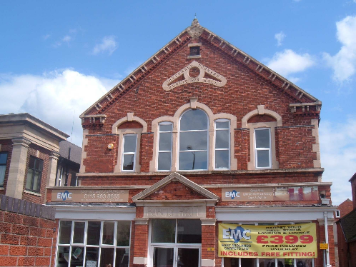
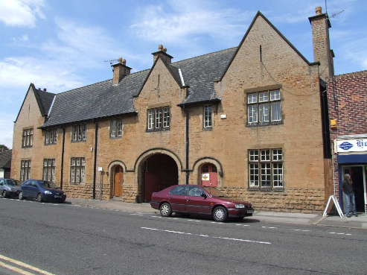
Hucknall Torkard Public Hall, Watnall Road; The Old Police Station, Brook Street, Sutton Built in 1875. Former police station constructed during
the edwardian period.

Military
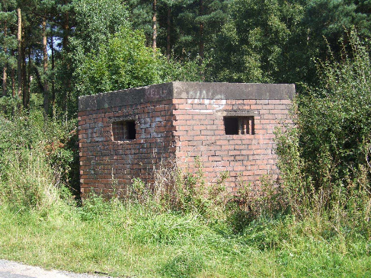
These buildings and structures help to represent the importance of the armed forces to the history of our society. They may be stand-alone structures (such as the former pill box in Underwood) or be within larger military sites such as airfields. In Ashfield, the WW1 airfield at Hucknall is particularly important as it contains a number of buildings and structures of significance and reflects the growing importance of air transport in the 20th –century together with the development of aircraft engines at Rolls Royce.

Type 26 WW2 Pill Box, Felley Mill Lane,
Underwood; Built as a gun post during WW2
at the junction of Felley Mill Lane North & South.

Park and Garden
Landscapes created as planned urban parks or to provide a visually pleasing setting to private residences, institutional establishments (including cemeteries) and certain utilities may contain buildings and structures which contribute positively to the character of a park, garden, landscape or wider area. These buildings/structures are often remnants of the English country house landscape tradition. They may also exhibit architectural features that reflect the fashions of their respective times. Such buildings and structures may be contained in (or on the boundaries of) areas such as private gardens, public parks, town squares, public walks, cemeteries or allotments.

Buildings and structures regarded as heritage assets may include follies, glass houses, cottages, bothies, fencing/walls/gates, steps, terraces, balustrading, statues, water features, bridges, paved walkways and driveways, amongst others. Many of these sites may also appear in the Nottinghamshire County Council list of non- registered Parks and Gardens.
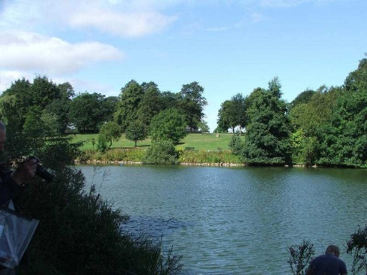
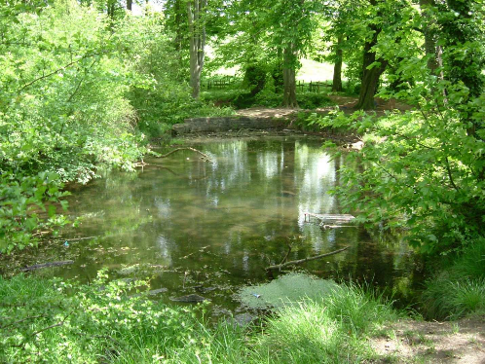
Sutton Lawn, Station Road, Sutton; Original Skegby Hall Gardens, Mansfield Road, 18th century garden of the Unwin family, Skegby; 18th century gardens, which once whose mansion once stood on Station Road. belonged to the adjoining Hall.

Places of Worship
Notwithstanding those places of worship that enjoy statutory protection, many unlisted religious sites exist which are of considerable architectural, archaeological, historical and artistic significance. Of particular prominence across the District are the large numbers of nonconformist chapels dating from the 18th century, some of which display considerable artistic features such as decorative central windows and date stones. Other places of worship prominent in the District are the Anglican churches of the late 19th Century, which again encompass significant architectural detailing such as stained glass windows and arched porches, although often simpler in their design than earlier structures.

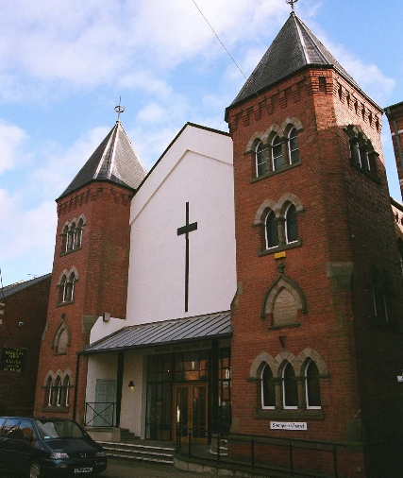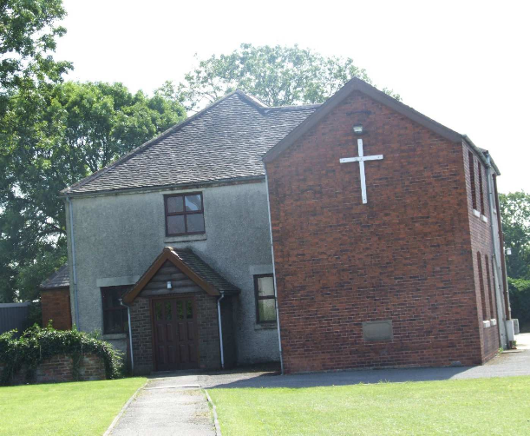
Baptist Church, Watnall Road, Hucknall; United Reform Church, 42 Nottingham Road, Selston; Featuring an imposing entrance and twin A pre-Victorian chapel with graveyard.
majestic towers.

Street Furniture and Historic Surfaces
The character of our street scenes is greatly enriched by historic street furniture and historic surfaces. Given that roads undergo constant change, street furniture is particularly vulnerable to these changes. Examples may include lamp posts, post boxes, telephone kiosks, milestones, directional signs, boundary walls, horse-related structures, bollards and drinking fountains. Many of these hold artistic, architectural or historic significance. Particularly rare are those structures such as drinking troughs that relate to horse-based transportation. The majority of street furniture of significance is likely to date from the Victorian period onwards (since little from before this time survives intact).
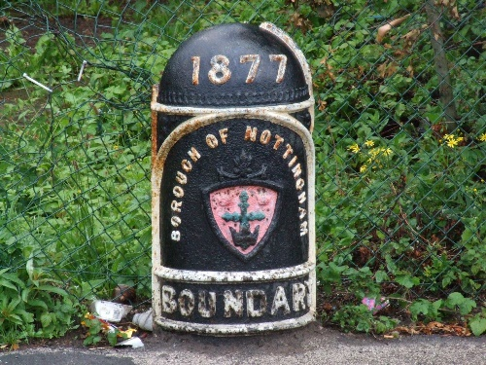
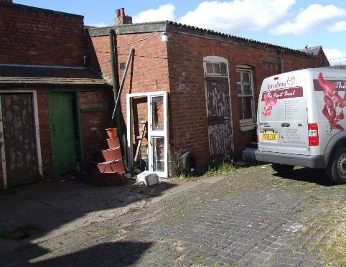
Boundary Marker, Hucknall Lane, Hucknall; Stable Yard , Behind 82-84 Station Road, Located on this spot in 1877 to mark the Kirkby: Late Victorian cobbled yard with boundary between Hucknall and Nottingham. original stables still surviving.

External street, pavement and yard surfaces are often a part of the historic environment that is overlooked, particularly during development works and the installation of underground services. Surfaces of significance may consist of (amongst others) materials including cobbles, brick or stone. Yorkstone flag surfaces are also of significance and usually date to between the late 18th and late 19th centuries. These surfaces enhance the setting of historic buildings and contribute to the character of the wider historic environment. They may also help link together otherwise separate clusters of buildings as an element of continuity.

Please note that there may be significant overlap between this section and the ‘Transport’ and ‘Communication & Utilities’ sections that follow.

Transport
Eighteenth and nineteenth century toll roads often had associated toll houses, such as the one in Selston, the proceeds from which financed road building/maintenance. Several toll houses still remain, some of which are not designated, although they are clearly of historic (and possibly architectural) interest. Later structures may also be of significance.

Rail travel has had a lasting impact on the landscape. The Mansfield to Pinxton Tramway (completed 1819) was originally a horse drawn tramway to move coal before the advent of steam power. Today it is regarded as the oldest continuously running train line in England. The rail lines are intrinsically connected with the colliery industry in Ashfield and as with the collieries themselves had numerous associated buildings such as station houses, signals and sidings. The routes themselves may also be of historic, architectural or artistic interest. Pedestrian and horse-related transport infrastructure may also be of significance, such as bridges over watercourses.

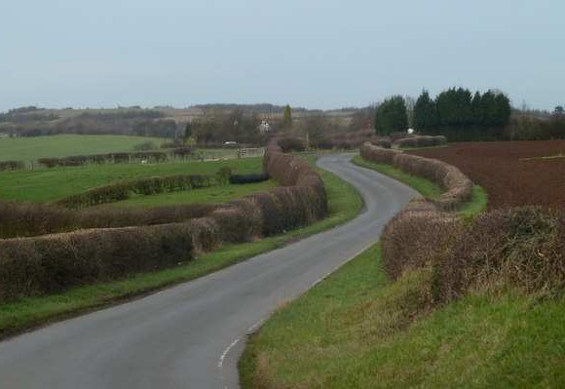
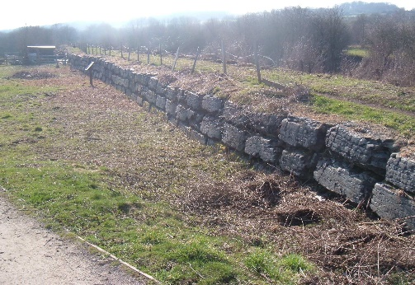
Please note that the air travel-related structures of significance in Ashfield (notably at Hucknall) have military origins and are therefore discussed in the Military category. In addition, directional signs and milestones have been included in the Street Furniture and Historic Surfaces category.
Dawgates Lane, Skegby; The medieval/Tudor Slag Block embankment, Wharf Green, highway between Nottingham Castle and Jacksdale; The only surviving embankment Bolsover Castle. of its type in England, which was used to
convey horse drawn carts along early rails from the Kirkby coal mines to the Butterley iron works.

Utilities and Communications
This category includes those heritage assets related to the supply of water, to sewage disposal, gas supply, electricity generation/supply and communications. Given their nature, these assets are usually functional although can often contain intricate decoration, both internally and externally. In addition, the functional parts of these structures may be of historic interest themselves. Examples may include water towers, water pumps, pumping stations, letter boxes, post offices, telephone repeater stations or telephone exchanges.

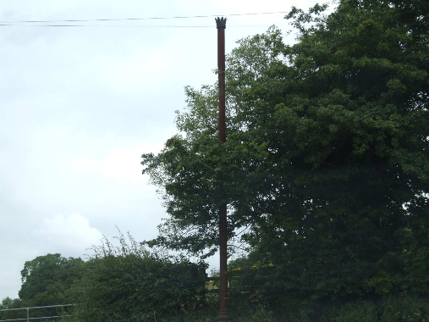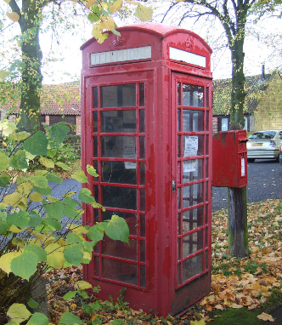
Breather Pole, Dawgates Lane, Skegby (near Telephone Box, Buttery Lane, Teversal; The Maypole PH): A rare example of the Victorian Traditional style red telephone box in Sewerage system of Skegby. local ownership.

Any other Building or Structure
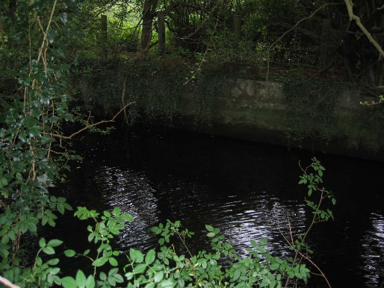
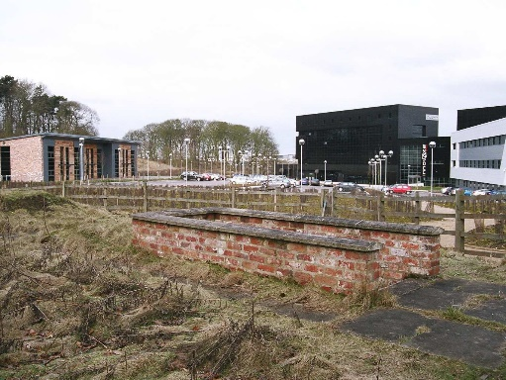
There may be buildings or structures of architectural, archaeological, historical or artistic significance that may not easily be grouped into one of the categories detailed in this section (such as boundary features). These should also be identified as heritage assets where appropriate.
Teversal Baths, Teversal Village: Private Ice House, Mansfield Road, Annesley; The Victorian swimming pool surrounded by a only known ice house in Ashfield originally grove of trees in the former grounds of dating back to the eighteenth century but Teversal Manor. relocated in the 1990s.

Archaeological Sites
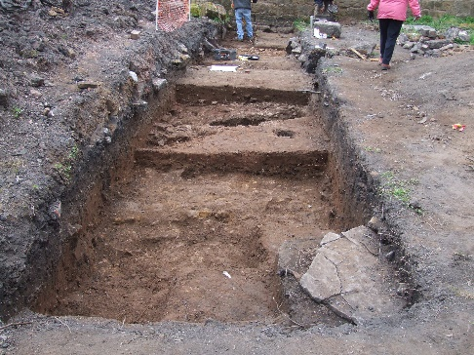
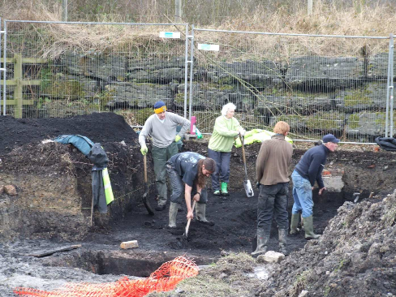
A large number of areas with archaeological interest are already identified on the Nottinghamshire County Council Historic Environment Record (HER). These existing sites are therefore already identified as Local (non-designated) Heritage assets for their archaeological interest.
Kirkby Hardwick, Penny Emma Way, Kirkby; Wharf Green, Jacksdale; A dig has been Site of a former manor house dating back to carried out under the direction of the Notts the mid 13th century, which has recently been County Council Heritage Team. This is the the site of two digs, under the direction of the site of former houses and early tram line. County Archaeologist.

In addition to these existing sites, new sites may come forward, either as a result of development works, agricultural practices, archaeological/local studies, metal detecting, and studies of aerial photography or local knowledge. Once these sites are acknowledged by the County Council as being of archaeological interest, they will receive policy protection as Local Heritage Assets (and subsequently added to the HER by Nottinghamshire County Council).

Landscapes and Landscape Features
In addition to buildings/structures and areas of archaeological interest, many landscapes and landscape features exist that are of historic and artistic (and sometimes archaeological) interest. Many of these sites have already been added to the Historic Environment Record (HER) by the County Council. Those on the HER are, therefore, already identified as heritage assets (such as unregistered parks and gardens, cemeteries, etc) for the purposes of this document.

Specifically with regard to unregistered parks and gardens, a large number of these exist within Ashfield, usually set around country houses (some of which were demolished in the 1950s/60s). Examples include Skegby Hall, Sutton Lawns and Annesley Hall. Please note however that some of these sites are also within Conservation Areas and some of the buildings/structures may also be listed, so are therefore designated assets for decision-making purposes. Nineteenth and twentieth century planned cemeteries are also included within this classification.

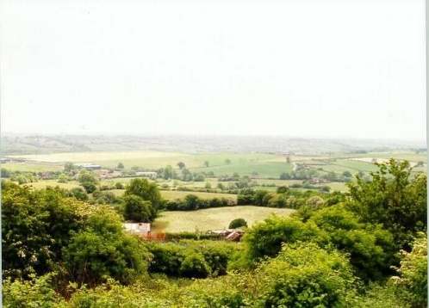
Strawberry Bank, Huthwaite: Believed to be the highest point in Nottinghamshire, overlooking a vast valley. Archaelogical surveys have
located the remains of an ancient Hill Fort on this site.

Other landscapes and landscape features that may be identified include public parks, historic village greens, cemeteries, mill ponds, man-made lakes, historic field patterns/enclosures, other water-management landscapes and features (such as weirs, feeder channels, etc), woodland and paths/trackways. Many of these are also identified in NottinghamshireCounty Council’s Historic Landscape Characterisation⁶ (HLC) project. Those sites identified of significance on the HLC may, therefore, be given weight as heritage assets for the purposes of this document.

⁶ http://www.nottinghamshire.gov.uk/learning/history/historicbuildings/heritageprojects/

Local Character Areas
Many settlements within Ashfield have a historic core that can easily be identified, usually due to the presence of early structures such as medieval churches, manor houses or industrial sites (mills for example). Often these settlements contain tightly bound road patterns around the centre that survive to this date. Examples of local character areas of medieval date include Teversal, Lower Bagthorpe and Kirkby Cross.

Other than those of medieval date, other local character areas may also be of significance as heritage assets. Mining communities, i.e. those settlements constructed to serve a particular coal mine, exist throughout the District, such as Annesley Rows and east Kirkby.
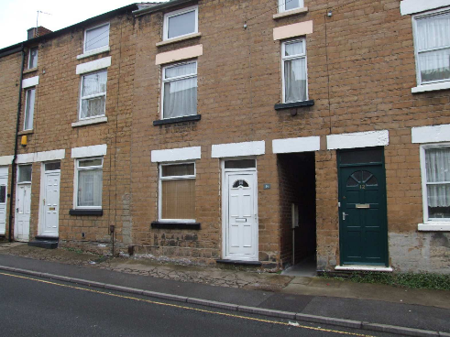
Albert Street, Hucknall; A street and associated Yards that feature a series of Knitters Cottages (mostly terraced) ranging from Georgian stone built to late Victorian red brick houses and workshops.

SECTION 8

- How to nominate a site for inclusion on the Local Heritage Asset List
  - Nominations for inclusion on the Local Heritage List should be made using the Nomination Form which is included at the back of this document. Additional copies can be downloaded from the Council’s website at www.ashfield-dc.gov.uk, or can be collected from reception at the Main Council Offices. These should be submitted by post or by email with a site plan and a good quality, recent photograph, to:

Forward Policy Team, Ashfield District Council, Urban Road,
Kirkby in Ashfield, Nottinghamshire, NG17 8DA.

Email: j.clayton@ashfield-dc.gov.uk Tel: 01623 457383

  - It is important that the nomination form is used to put forward a building, structure or place because it asks for the information needed to include an item on the List - about why the building or structure or place is important, where it is, how old it is, and so on. A contact for the person putting the suggestion forward is requested because sometimes it is necessary to check on details of the information.

  - Occasionally the District Council itself undertakes surveys of particular areas to identify potentially eligible buildings/structures. Such surveys (including photographs) are always done from public land unless owners give permission to access private property. Surveyors undertaking such work will always carry identification and will be happy to advise you about what they are doing and the project in general, including providing copies of this document.

SECTION 9

Consultation
  - If your building has been nominated for Local Heritage Listing, it is important to note the following:
    - Inclusion on the Local Heritage Asset List does not make your building a ‘Listed Building’ – it is a local designation only;
    - Nomination of a building does not mean it will definitely be included on the Local Heritage Asset List;
    - You can have your say about whether your building deserves inclusion or not;
    - No personal details, internal photographs or photographs of private land will be contained on the Local Heritage Asset List without permission however it is helpful for each asset to be photographed.

  - It is important to remember that the Council can only consider comments about the buildings level of local architectural or historic interest, and we can not consider personal circumstances, or current or future development proposals.

SECTION 10

Sources of further information
  - Many bodies, groups and societies produce information for specific periods or types of architecture and can be very useful for identifying heritage assets. Useful sources of information include:

    - English Heritage
    - Nottinghamshire County Council
    - North East Midlands Photographic Record
    - The Victorian Society
    - The Georgian Group
    - The Twentieth Century Society
    - Society for the Preservation of Ancient Buildings (SPAB)
    - Council for British Archaeology
    - Institute for Archaeologists
    - Garden History Society
    - The Association for Industrial Archaeology
    - Institute for Historic Building Conservation (IHBC)
    - Pevsner’s architectural guides
    - Victoria County Histories
    - Heritage Gateway
    - War Memorials Trust

Please note that the above list is not exhaustive and other organisations/groups may also prove useful.

ASHFIELD LOCAL HERITAGE LIST
NOMINATION FORM
Details of person making the nomination |  |  |  |  |  |  |  |  |  |  |  |  |  |  |  | This form, together with relevant supporting information should be sent to:  Forward Planning Team, Ashfield District Council, Urban Road,  Kirkby-In-Ashfield, Nottinghamshire, NG17 8DA.  E: j.clayton@ashfield-dc.gov.uk T: 01623 457383
Name: Address:

Telephone No: Email:
Details of Building/Structure (including Archaeological Sites, Landscapes and Landscape Features)
Brief Description (e.g. 1930’s dwelling, stone chapel, pillar box, garden):

Address:

Post Code: Grid Reference (if known):
The following questions are important for the support of your nomination.
1. How old is the main part of the building, structure, park or garden? Please tick
Pre-1700 |  |  |  |  |  | 1700-1840  (Georgian) |  |  |  |  | 1840-1914  (Victorian) |  |  | 1914-1940  (Inter-war) |  |  |  |  |  | Post 1940 (Modern)
If a definite date is know, what is it?
Date |  |  |  |  |  |  | Source
2. Is the building or structure in a recognisable form, retaining historic features and layout? Please tick
Completely intact |  |  |  |  |  |  | Largely intact |  |  |  | Partially intact |  |  |  | Largely spoilt |  |  |  | Completely spoilt
3. If it is a building, is it occupied?
Yes |  |  |  |  | No |  |  | If yes, name and address of owner if known.

3. Why, in your opinion, should the building or structure be included on the Local Heritage Asset List? Please answer based on the Local Heritage Asset List Criteria. Sections 6.4 to 6.7 examine the types of interest a potential heritage asset may have. Sections 6.8 to 6.12 provide criteria that can be used to assess the significance of this interest. Please provide as much information as possible to
support your nomination.
Supporting Information -
A map should be included in order to identify the location of the building or structure.
Map |  |  | Photographs |  |  |  |  | Other
For Office Use Only
On HER |  | Yes/No | Listed | Yes/No |  | Conservation Area |  |  | Yes/No
Recommend to add  to list |  |  | Yes/No | Officer Name

If you require any assistance in completing this form or if you would like additional copies, please contact the Forward Planning Team on 01623 457383, alternatively the form can be downloaded from the Council’s web site at: www.ashfield-dc.gov.uk .
This form is also available in large print and where appropriate, other formats may be available upon request.

Your personal information will be handled by Ashfield District Council in accordance with the Data Protection Act 1998. Your information will not be disclosed to third parties. This page will not be displayed on our website but may be made available for public inspection at our offices.

This document is available in larger print and where appropriate,
other formats may be available upon request.

Ashfield District Council Forward Planning Team
Urban Road, Kirkby-in-Ashfield, Nottingham, East Midlands, NG17 8DA
Tel: (01623) 457381 / 457382 / 457383 Fax: (01623) 457332

